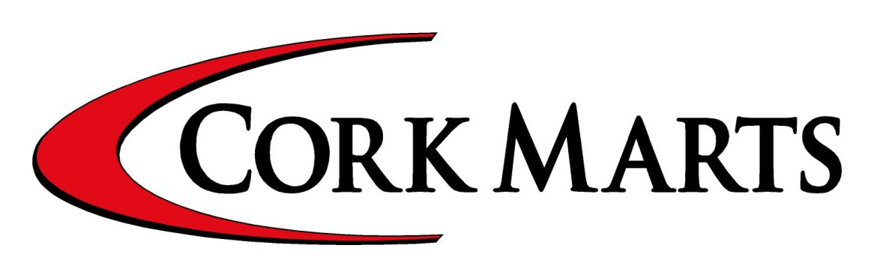
FARM TO FARM DAIRY SLAES
Wanted Dairy Stock for local customers plus exporting to Northern Ireland & UK.
Contact: John Foley, Cork Marts
086 8746454

Cork Marts Newsletter 5 April 2012
BANDON MART
023 8841151/086 8279873
Each Monday:
Cattle 11.30.Calf Sale 11 a.m.
Calf intake opens at 8 am.
Sheep 10.30am. Special Section for
finished Cattle each Monday
Manager: Tom McCarthy.
CORRIN MART
025 31611 / 086 3821846
Each Monday:
Sheep Sale at 11 a.m. with special
section for Breeding Sheep.
Each Tuesday:
Cattle & Calf Sale at 11.30am
Manager: Sean Leahy.
DUNGARVAN MART
(58 41611/ 086 2528984
Each Monday:
Cattle Sale at 12 Noon.Calf Sale 11.30 am sharp, intake opens at 8.30 a.m.
Manager: Ger Flynn.
CAHIR MART
(02 7441307/087 6125356
Each Wednesday:
Cattle 12.30 Calves 11.30am
Sheep 11.30am
Factory Assembly Centre for Sheep
each Tuesday at 8 am
Manager: Jonathan O’Sullivan.

SKIBBEREEN MART
(08 21066/086 8279873
Each Friday:
Cattle Sale at 12 Noon.
Calf sale 11.30 intake open 8 am. Special section for Fr. Hfr. Calves each Friday at 12.30pm.Pre-entry advisable.
Manager: Tom McCarthy.

MACROOM MART
(06 41121/087 2820031
Each Saturday:
Cattle 11.30 a.m.
Intake opens at 8am.
Factory Assembly Centre For
Sheep Each Wednesday.
Manager: John O’Mahony
Cork Mart Locations
DIY AI Training Courses at Macroom Mart

Top dairy and beef semen available
Equipment and liquid nitrogen sales

Contact Jerh O’Sullivan 086 8329321
DIY insemination.Training courses
Department of Agriculture approved
Special Mid Term Couses for Students commencing 2nd April

GOOD FRIDAY -
Skibbereen:
Cattle & Calf Sale.
Corrin: Dairy Sale

EASTER SATURDAY
Cattle & Calf Sale at Macroom

USUAL SALES EASTER MONDAY –at Bandon, Corrin & Dungarvan

Dungarvan Mart
General Cattle & Calf Sale Monday next 9 April at 12 Noon (Easter Monday)

Special Dairy Sale Thurs. 12 April, 12 Noon Of Maiden Hfrs. Calved & in calf Hfrs also Calved Cows. Entries & Enquiries to Dungarvan mart

WANTED: Friesian Bull Calves. Heavy Dry Cows Continental Heifers 350kgs upwards.
ALSO: Aberdeen Angus & Hereford Heifers & Bullocks for further feeding.

Skibbereen Mart
Usual Cattle & Calf Sale Good Friday.

Dairy Sale & Suckler Sale each Friday
Also Special Section for Fr. Maiden Heifers
Including 7 Ped Dairy Heifers (Friday 6 April)
Herd Av. 1280gl 3.55 Pro 4 % B/F For: Michael & Marguerite Crowley, Baurvilla, Skibbereen

Machinery & Equipment Auction
Saturday 21 April 2012
Entries close Tuesday 10 April.

To lease: c30 acres at Carrigbawn, Drinagh With Entitlements 028 21066
Bandon Mart
Strong enquiries for Dry Cows, Bullocks & Hfrs.

NEXT DAIRY SALE THURS. 12 APRIL
Special Entry: Complete Clearance Sale
On Behalf of Mr Jerry O’Sullivan,
Lislevane North, Bandon
40 TOP CLASS A.I BRED FR. COWS
Herd Ave. in 2011. 1,824gls 3.42pr 3.93bf.
Average EBI 90

All Breed Bull Sale Weds. 18 April ‘12
Corrin Mart
LAMB SALE MONDAY NEXT 9 APRIL
Dairy Sales each Friday –

Dairy Sale Friday 6 April, 110 on offer.

Dairy Sale Friday next, 13 April 180 on offer.

Aberdeen Angus Bull Sale 4 May.
All breed bulls on Friday 11 May

Head Office Cork Marts
2A North Point House,
North Point Business Park,
New Mallow Road, Cork
021 4220400

Email: info@corkmarts.com
www.corkmarts.com
www.ccmproperty.com
Cattle & Calf Collection and Selling Service available in all areas. Contact local mart.

BANDON MART
023 8841151 / 086 8279873

Each Monday:
Cattle 11.30.Calf Sale 11.am
Calf intake open at 8 am.
Sheep 10.30am. Special Section for
finished Cattle each Monday
Manager: Tom McCarthy

CORRIN MART
025 31611 / 086 3821846

Each Monday:
Sheep Sale at 11 a.m. with special
section for Breeding Sheep.
Each Tuesday:
Cattle & Calf Sale at 11.30am
Manager: Sean Leahy
DUNGARVAN MART
058 41611/ 086 2528984

Each Monday:
General Cattle & Calf sale at 12 Noon.
Manager: Ger Flynn.

CAHIR MART
052 7441307 / 087 6125356
Each Wednesday:
Cattle 12.30 Calves 11.30am
Sheep 11.30am
Factory Assembly Centre for Sheep
each Tuesday at 8 am
Manager: Jonathan O’Sullivan

SKIBBEREEN MART
(28 21066/086 8279873
Each Friday: Cattle Sale at 12 Noon.
Calf sale 11.30 intake open 8 am.Special section for Fr. Hfr. Calves each Friday at 12.30pm. Pre-entry advisable.
Manager: Tom McCarthy

MACROOM MART
(06 41121/087 2820031
Each Saturday:
Cattle 11.30 a.m.
Intake opens at 8am.
Factory Assembly Centre For
Sheep Each Wednesday.
Manager: John O’Mahony.
Cork Mart Locations
DIY AI Training Courses at Macroom Mart

Top dairy and beef semen available
Equipment and liquid nitrogen sales

Contact Jerh O’Sullivan 086 8329321
DIY insemination
Training courses
Department of Agriculture approved

FARM TO FARM DAIRY SLAES
Wanted Dairy Stock for local customers plus exporting to Northern Ireland & UK.
Contact: John Foley, Cork Marts
086 8746454
Cork Marts Newsletter 5 April 2012
Cattle & Calf Collection and Selling Service available in all areas. Contact local mart.

Cahir Mart
Wanted Heavy Dry Cows,

Forward Store Bullocks and Heifers. Contact Cahir mart.

Macroom Mart
Usual Cattle & Calf Sale Easter Saturday.

Suckler Sale Sat. 14 April
Entries to Macroom Mart.

Buying or Selling Entitlements -
Strong enquiries -
Contact
CCM Property Network
Bandon 023 8820966,
Skibbereen 028 210666

LETTINGS

- To Let: Rathrout, Ballinadee
C 18 acres 1st cut silage
- Gurranreigh, Lissarda
23 Acres of 1st cut Silage
- Lislee, Courtmacsherry
12 Acres for 2 cuts Silage
- To Let/ Lease: Kilronan East, Dunmanway
C. 40 Acres – all in grass. Some suitable
for tillage. (Can be let in lots)
- To Let: Nedineagh, Dunmanway
C. 40 Acres For Grazing / Tillage.

 CCM Bandon 023 8820966

GRASSLAND LETTINGS WITH MAPS:
- Britway, Castlelyons:
C33 Acres
- Saleen, Midleton: C 12 Acres
- Killacluig, Mitchelstown
C76 Acres
- Drough, Mitchelstown
C55 Acres in 1 or 2 lots
- Rathcormac/Castlelyons
C27 Acres

CCM Mitchelstown 025 41129

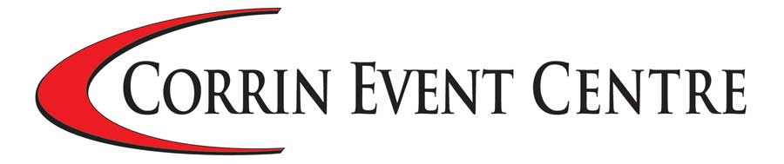

Enquiries & Bookings for
Corrin Event Centre –

Contact Catherine Dorgan,
Event Co-ordinator 025 31611
www.corrineventcentre.com

